Poster Paper Submission.

o Research Article based on recent technical trends need to be submitted by students : Maximum 20 marks.

CO Mapped

CO2: Comprehend significance of regular expressions, grammars and its equivalence

with automata

CO3: Understand advanced concepts in computation

TOPIC(Practical Applications/ Case Studies/Research ) for Poster Paper Presentation:

Automata Theory in Machine Learning

Rubrics for Poster Presentation:

Content Clarity: Overview of automata theory's role in machine learning.

Depth of Research: Examples of machine learning algorithms that utilize automata.

Visual Appeal: Flowcharts and models showing the integration of automata in ML algorithms.

Presentation Skills: Effective communication of technical content.

| Content Clarity | 5 |
| --- | --- |
| Depth of Research: Examples of Automata | 5 |
| Visual Appeal | 5 |
| Presentation Skills | 5 |
| Total | 20 |

**______________________________________________________________________________**

### **Section 1: Introduction**

#### **Automata Theory Overview (Top Left)**

Automata theory is a branch of computer science that provides **mathematical models** to understand computation through **finite automata, pushdown automata,** and **Turing machines**. These models analyze how systems transition between states in response to inputs, offering insights into the behavior and efficiency of various algorithms.

#### **Relevance to Machine Learning (Top Right)**

Automata theory offers a **structured approach** to analyzing machine learning (ML) algorithms by modeling data flows, decision processes, and state transitions. This theory is especially relevant to algorithms such as **Hidden Markov Models (HMMs)** and **Recurrent Neural Networks (RNNs)**, where states and transitions are fundamental to how these models operate.

**Visual Suggestion:**

* **Diagram of finite automata** illustrating states and transitions.
* A **flowchart** showing how automata theory relates to ML algorithms like RNNs and HMMs.

### **Section 2: Machine Learning Algorithms Using Automata**

#### **2.1 Recurrent Neural Networks (RNNs)**

* **Overview:**RNNs are a type of neural network that use **feedback connections** to process sequential data, allowing them to "remember" previous inputs. This makes them particularly useful in tasks such as **language modeling** and **time series prediction**.
* **Automata Connection:**RNNs are similar to finite state machines in that their outputs depend not just on current inputs but also on **previous states**. Each hidden layer can be viewed as a state in an automaton, making them conceptually akin to **automata with memory**.

**Visual Suggestion:**

* Diagram showing **RNN structure**, highlighting the data flow and state transitions.

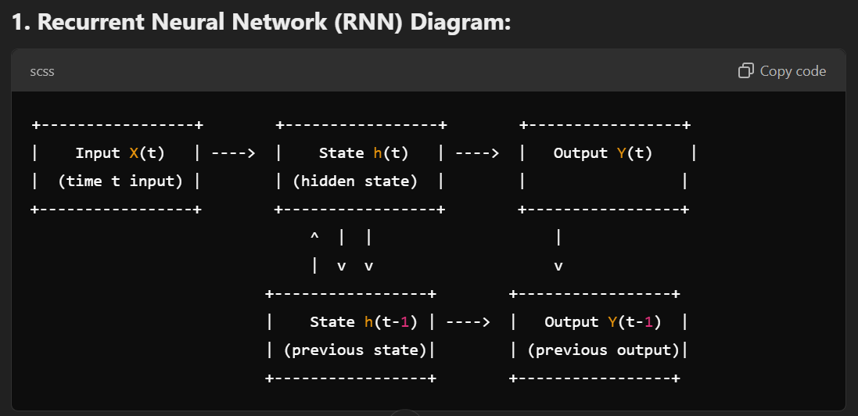

**Explanation:**

The diagram shows an RNN with the current input X(t) at time t, processed through a hidden state h(t), which depends on the previous state h(t-1). The output at each time step is Y(t) and Y(t-1), influenced by both the current and previous states.

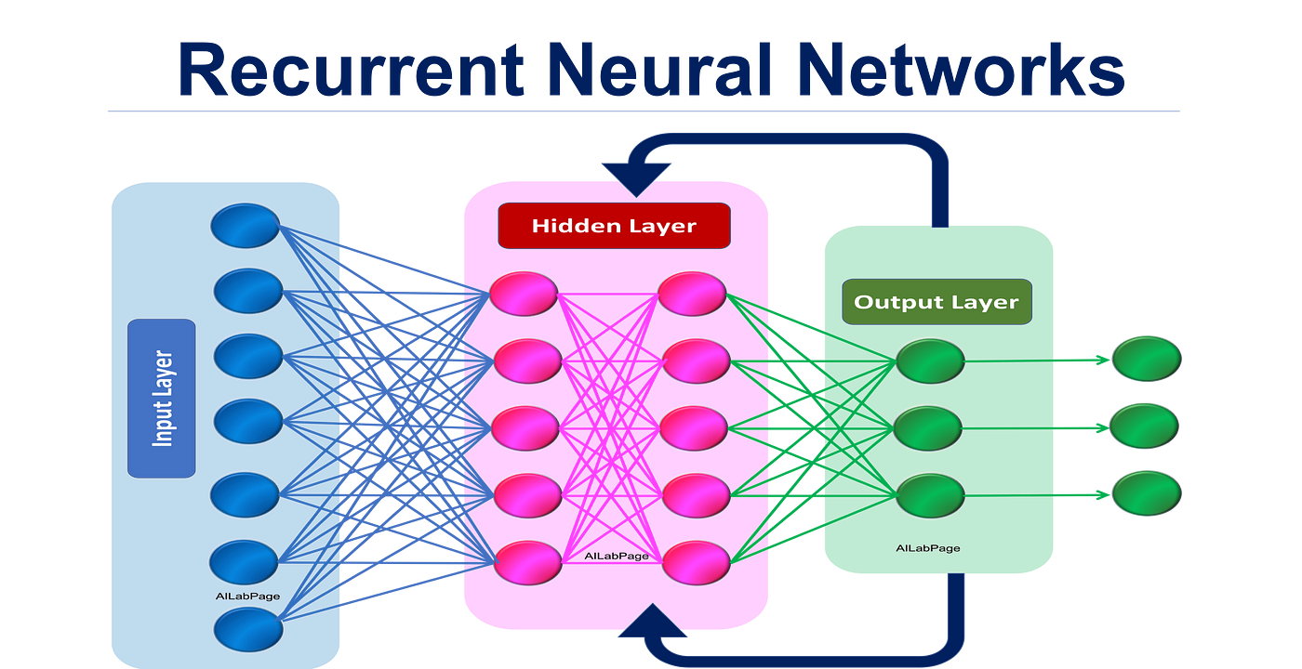

#### **2.2 Hidden Markov Models (HMMs)**

* **Overview:**HMMs are probabilistic models in which the system’s internal states are hidden, but the output is observable. They are used in **speech recognition**, **bioinformatics**, and **time-series forecasting**.
* **Automata Connection:**HMMs function like **stochastic automata**, where the system transitions between hidden states based on probabilities. These transitions can be modeled using automata principles, making them highly effective for applications involving sequential or temporal data.

**Visual Suggestion:**

* **State transition diagram** showing hidden and observable states in an HMM, along with transition probabilities.

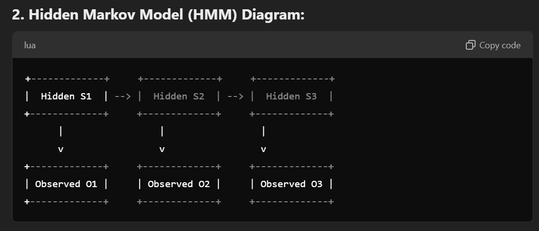

**Explanation:**

This diagram represents an HMM where hidden states S1, S2, and S3 represent the system's underlying process. Each hidden state corresponds to an observable output O1, O2, O3, which we can measure, while the actual states remain hidden.

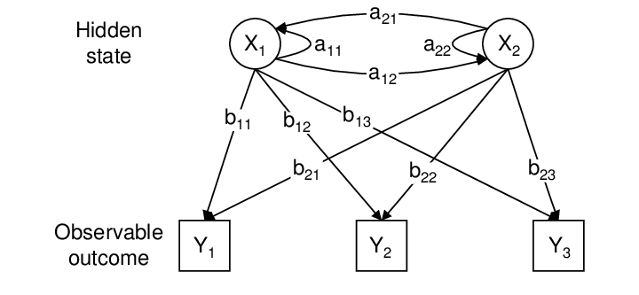

#### **2.3 Support Vector Machines (SVMs)**

* **Overview:**SVMs are supervised learning models used for **classification** and **regression** tasks. They find a **hyperplane** in a high-dimensional space to separate different classes of data points.
* **Automata Connection:**The class boundaries in SVMs can be thought of as states in an automaton, where each state represents a decision-making process about which class a data point belongs to. This connection highlights how SVMs use **state-based decisions** to optimize classification.

**Visual Suggestion:**

* A diagram showing **hyperplanes and support vectors** in 2D space, representing transitions between decision states.

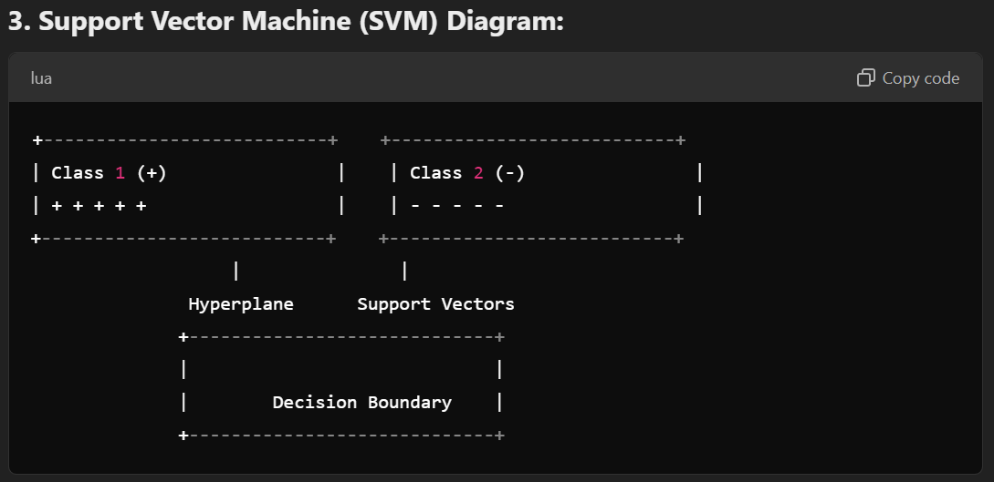

**Explanation:**

The SVM diagram shows two classes (+ and -) with a **hyperplane** separating them. The **support vectors** are the data points closest to the hyperplane that influence the position and orientation of the decision boundary.

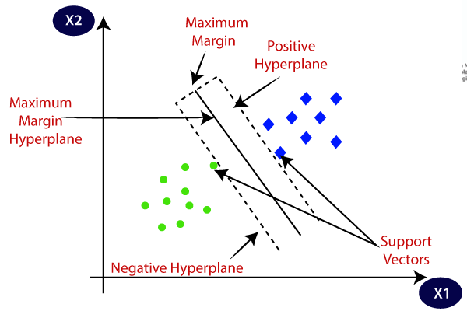

**3.1 NLP & Speech Recognition (RNNs & HMMs):**

* **Practical Application:**
  + RNNs: Used in **language translation** and **sentiment analysis**.
  + HMMs: Key in **speech recognition systems** like Siri and Alexa.
* **Case Study:**
  + **Google Translate:** RNNs handle sequential input to predict the next word.
  + **Voice Assistants:** HMMs model spoken language transitions for speech-to-text.
* **Visual Suggestion:** Icons for speech, text, and NLP tasks.

**3.2 Image Classification (SVMs):**

* **Practical Application:**
  + SVMs: Applied in **facial recognition** and **object detection**.
* **Case Study:**
  + **Medical Imaging:** SVMs classify MRI scans (e.g., healthy vs. cancerous).
* **Visual Suggestion:** Flowchart showing image classification with SVM.

**3.3 Bioinformatics (HMMs):**

* **Practical Application:**
  + HMMs: Used for **gene prediction** and **sequence alignment**.
* **Case Study:**
  + **HMMER Software:** Predicts gene sequences using automata-based models.
* **Visual Suggestion:** Icon for gene prediction linked to HMM diagram.

### **Section 4: Conclusion**

(Bottom Left)

* **Summary:**Automata theory provides a **foundational framework** for understanding machine learning models. By modeling state transitions and decision-making processes, automata theory enhances algorithms like **RNNs**, **HMMs**, and **SVMs**, leading to **practical applications** in **NLP**, **image classification**, and **bioinformatics**.
* **Future Prospects:**The integration of automata theory with ML continues to offer promising advances in **efficiency**, **model interpretability**, and applications in complex real-world systems.

### **Section 5: References**

(Bottom Right)

**C. Olah, "Understanding LSTM Networks," Colah's Blog, Aug. 2015.**Available:<https://colah.github.io/posts/2015-08-Understanding-LSTMs/>

* This blog post provides a detailed explanation of **Recurrent Neural Networks (RNNs)** and how they relate to automata theory through their handling of sequences.

**M. Mohri, F. C. N. Pereira, and M. Riley, "Weighted Finite-State Transducers in Speech Recognition," Journal of Machine Learning Research, vol. 10, pp. 417-440, 2009.**Available:<https://www.jmlr.org/papers/volume10/mohri09a/mohri09a.pdf>

* This research article is directly relevant to **Hidden Markov Models (HMMs)** and their automata-based approach in **speech recognition**.

**T. Joachims, "Making large-scale SVM learning practical," in Advances in Kernel Methods - Support Vector Learning, MIT Press, 1999.**Available:<https://www.cs.cornell.edu/people/tj/svm_light/svm_tutorial.pdf>

* This paper covers the practical application of **Support Vector Machines (SVMs)**, explaining the connection to automata theory in classification tasks.

**D. Eddy, "Hidden Markov Models and Other State-Space Models," Current Opinion in Genetics & Development, vol. 6, no. 6, pp. 687-694, Dec. 2009.**Available:<https://pubmed.ncbi.nlm.nih.gov/20059429/>

* This article discusses the use of **HMMs in bioinformatics**, particularly in **gene prediction** and **sequence alignment**, with automata-based principles.

**H. Bourlard and N. Morgan, Connectionist Speech Recognition: A Hybrid Approach, Kluwer Academic Publishers, 1994.**Available:<https://link.springer.com/chapter/10.1007/978-3-319-23525-7_30>

* This book chapter provides a hybrid approach to **speech recognition**, blending **automata theory** and **neural networks**.